**Subtraction Binary**

**Introduction**

In this assignment, I will be explaining how subtraction is used within binary. I will give an example of how it looks like and I will solve it for you as well.

This is very different to all of the ones that we have looked at so far. We need to know what twos compliment is before we move on to subtraction, as we cannot solve anything unless this is one and complete. Twos compliment is keeping the entire zeros the same unless you see a one. Once you see a one, you have to flip all of the rest. You do not do it to both of the 8 bit binary. You only do it to the second one, not the first one.

**Example**

00001010 One of the zero is flipped once they saw the one.

11011101

Once this is complete, you use binary addition to complete subtraction. For example in an exam, it would look like this: perform these subtractions

11) 00111011 – 00000000 = 00111011

**You cannot flip any of these, as they are no ones in it. It would stay exactly how it is. All you do is add it and get your answer. The answer would stay the same, as they are no ones to add it with. Adding zeros to the whole 8 bit would make it stay exactly how it is.**

01011001  
01110101

11001110

111 1

**RULES**

**0*0 = 0**

**0*1= 1**

**1*0= 1**

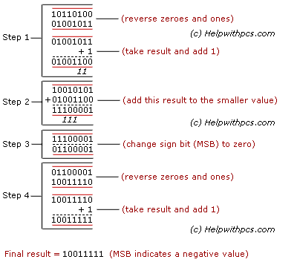**1*1= 0 carry 1**